**Advance Excel Assignment 5**

1. How many types of conditions are available in conditional formatting on Excel?

There are 5 types of conditional formatting visualizations available

* **Background Shading**

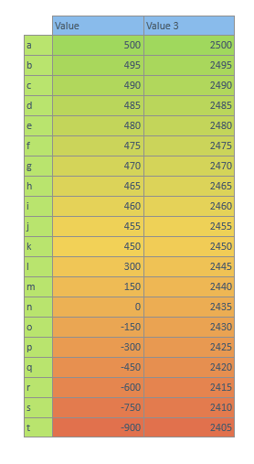

* **Foreground Shading**

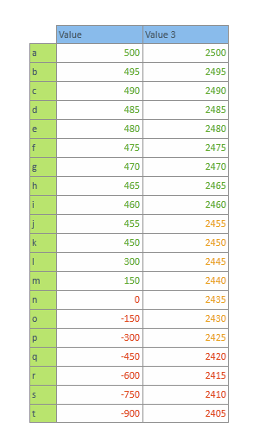

* **Databars**

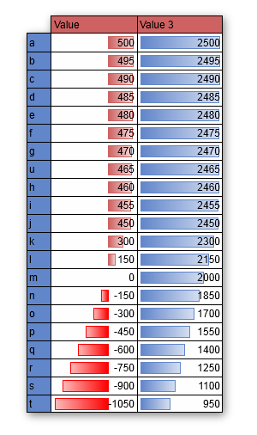

* **Icons (4 types)**

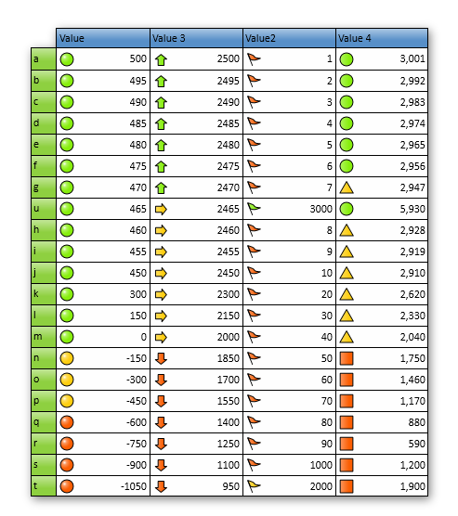

* **Values**

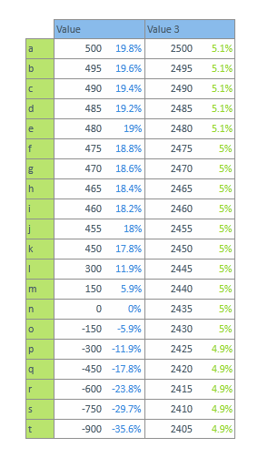

1. How to insert border in Excel with Format Cells dialog?

Steps to insert border in Excel with Format Cells dialog

1. Select a cell or a range.
2. Click the home tab.
3. 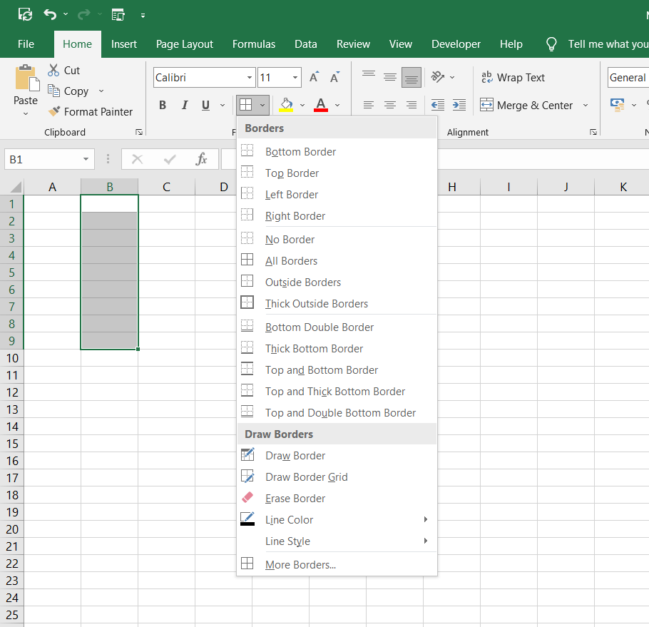Click the borders button arrow and then click more borders.
4. The format cell dialog box opens, select the border tab.

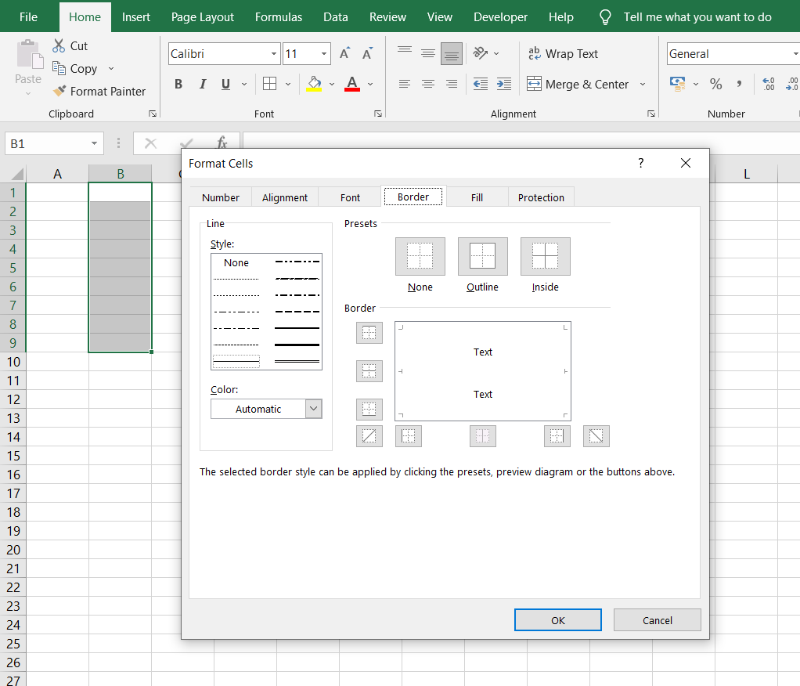

1. Select a line style.
2. Click the colour list and select the colour for the border.

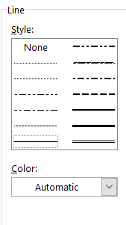

1. If we want a border on the outline of the cell range, **click outline.**
2. If we want a border between cells, **click inside**
3. If we want to remove the border, **click none**.

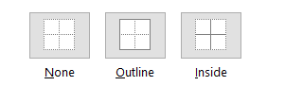

1. To set a custom border, select a border under the borders option.

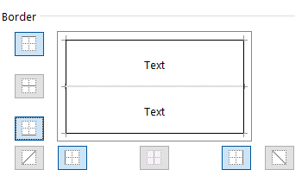

1. Click OK.

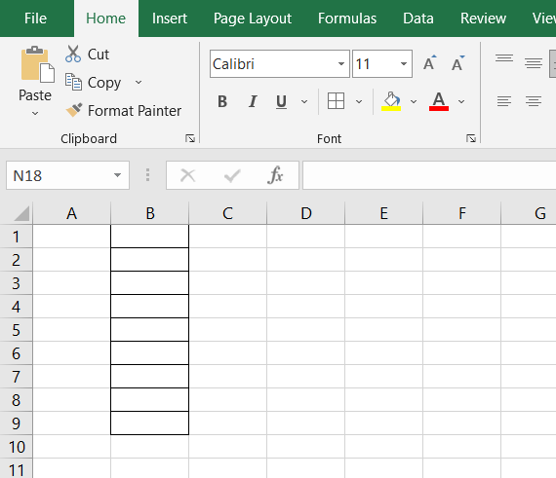

1. How to Format Numbers as Currency in Excel?

To show numbers as currency, you can apply either the Currency format or the accounting format.

**STEPS:**

* Select the cells that we want to format and then, in the numbers group on the home tab, click the down arrow in the number format box.
* Choose either Currency or Accounting.

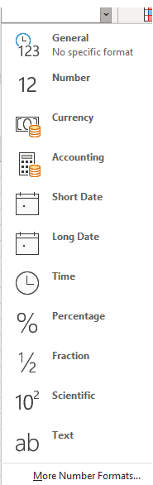

1. What are the steps to format numbers in Excel with the Percent style?

To quickly apply percentage formatting to selected cells, click **Percent Style** Button image in the **Number** group on the **home** tab, or press **Ctrl+Shift+%**. If you want more control over the format, or you want to change other aspects of formatting for your selection, you can follow these steps.

* On the **Home** tab, in the **Number** group, click the icon next to **Number** to display the **Format Cells** dialog box.

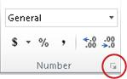

* In the**Format Cells** dialog box, in the **Category** list, click **Percentage**.

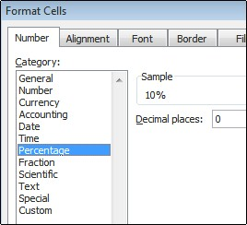

* In the **Decimal places** box, enter the number of decimal places that you want to display. For example, if you want to see **10%** instead of **10.00%**, enter **0** in the **Decimal places** box.

1. What is a shortcut to merge two or more cells in excel?

The following are the keyboard or key tips for merging cells:

* Merge and center- Alt > H > M > C
* Merge across- Alt > H > M > A
* Merge cells- Alt > H > M > M

1. How do you use text commands in Excel?

To use text commands in excel

=TEXT(Value you want to format, “Format code you want to apply”)